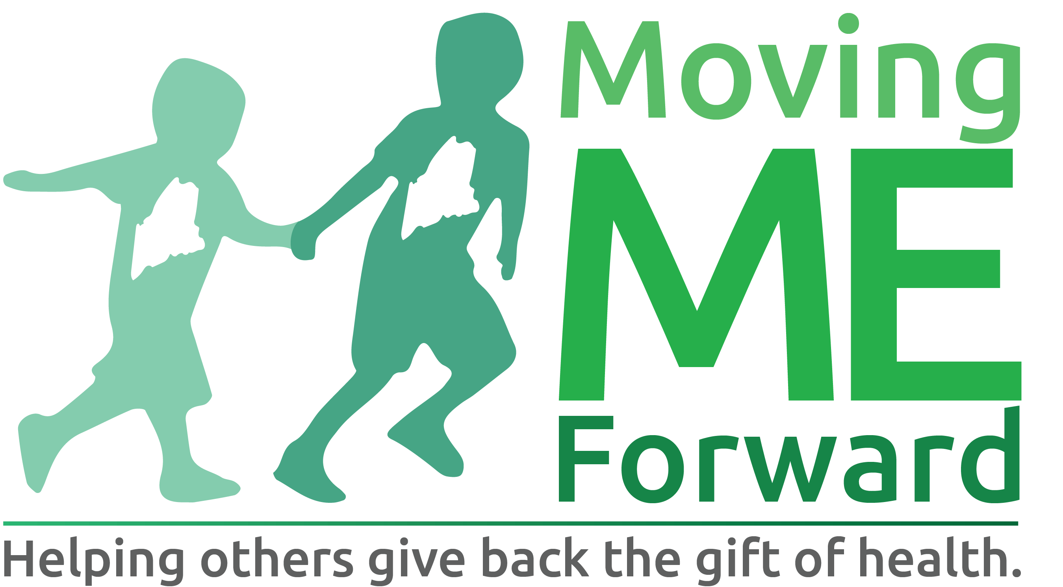 PROJECT PROGRESS REPORT

Directions:
All recipients of Moving ME Forward grants are required to complete this progress report form. Timeline for submission of progress reports will be established at the time of grant award.

Grantee
Project Title
Grant Award Date/Amount
Project Coordinator
Phone/Email
Progress Report Date

- At this time, the proposed project is (check one):
☐ Complete ☐ In Progress. Estimated Completion: ______ ☐ Not Yet Begun
If the project has not been started yet, please explain why and give an estimate of the start and completion dates.

- Estimate how many people have participated in or have been served by this project. _______
  - Is this level of participation (check one)
☐ lower than expected ☐about what was expected ☐higher than expected
  - Briefly explain what factors may have affected the level of participation (positively or negatively)

- Describe one of the most important project results or outcomes that you identified in your original grant application.

  - Check the number that best reflects the progress made towards this result.

☐ 1 | ☐ 2 | ☐ 3 | ☐ 4 | ☐ 5
Very little or no progress | Some progress | Significant progress | Result achieved | Exceeded expected result
  - Briefly explain your answer

  - Please describe any factors (positive or negative) that affected your progress toward this result.

- Please share one success story related to your project.

- If you could do this project again, what would you do differently?

- Please describe briefly and in general terms that challenges and the benefits you have experienced as a result of trying to use a partnership or collaboration to plan, implement, or evaluate this project.

Optional:
Please use this space to share any other suggestions, ideas or feedback you wish to give Moving ME Forward.

Thank you!

Please email this form to bbrainerd@cmcc1.com or mail to:
Moving ME Forward
Attn.: Bob Brainerd
21 Millett Drive
Auburn, ME 04210

