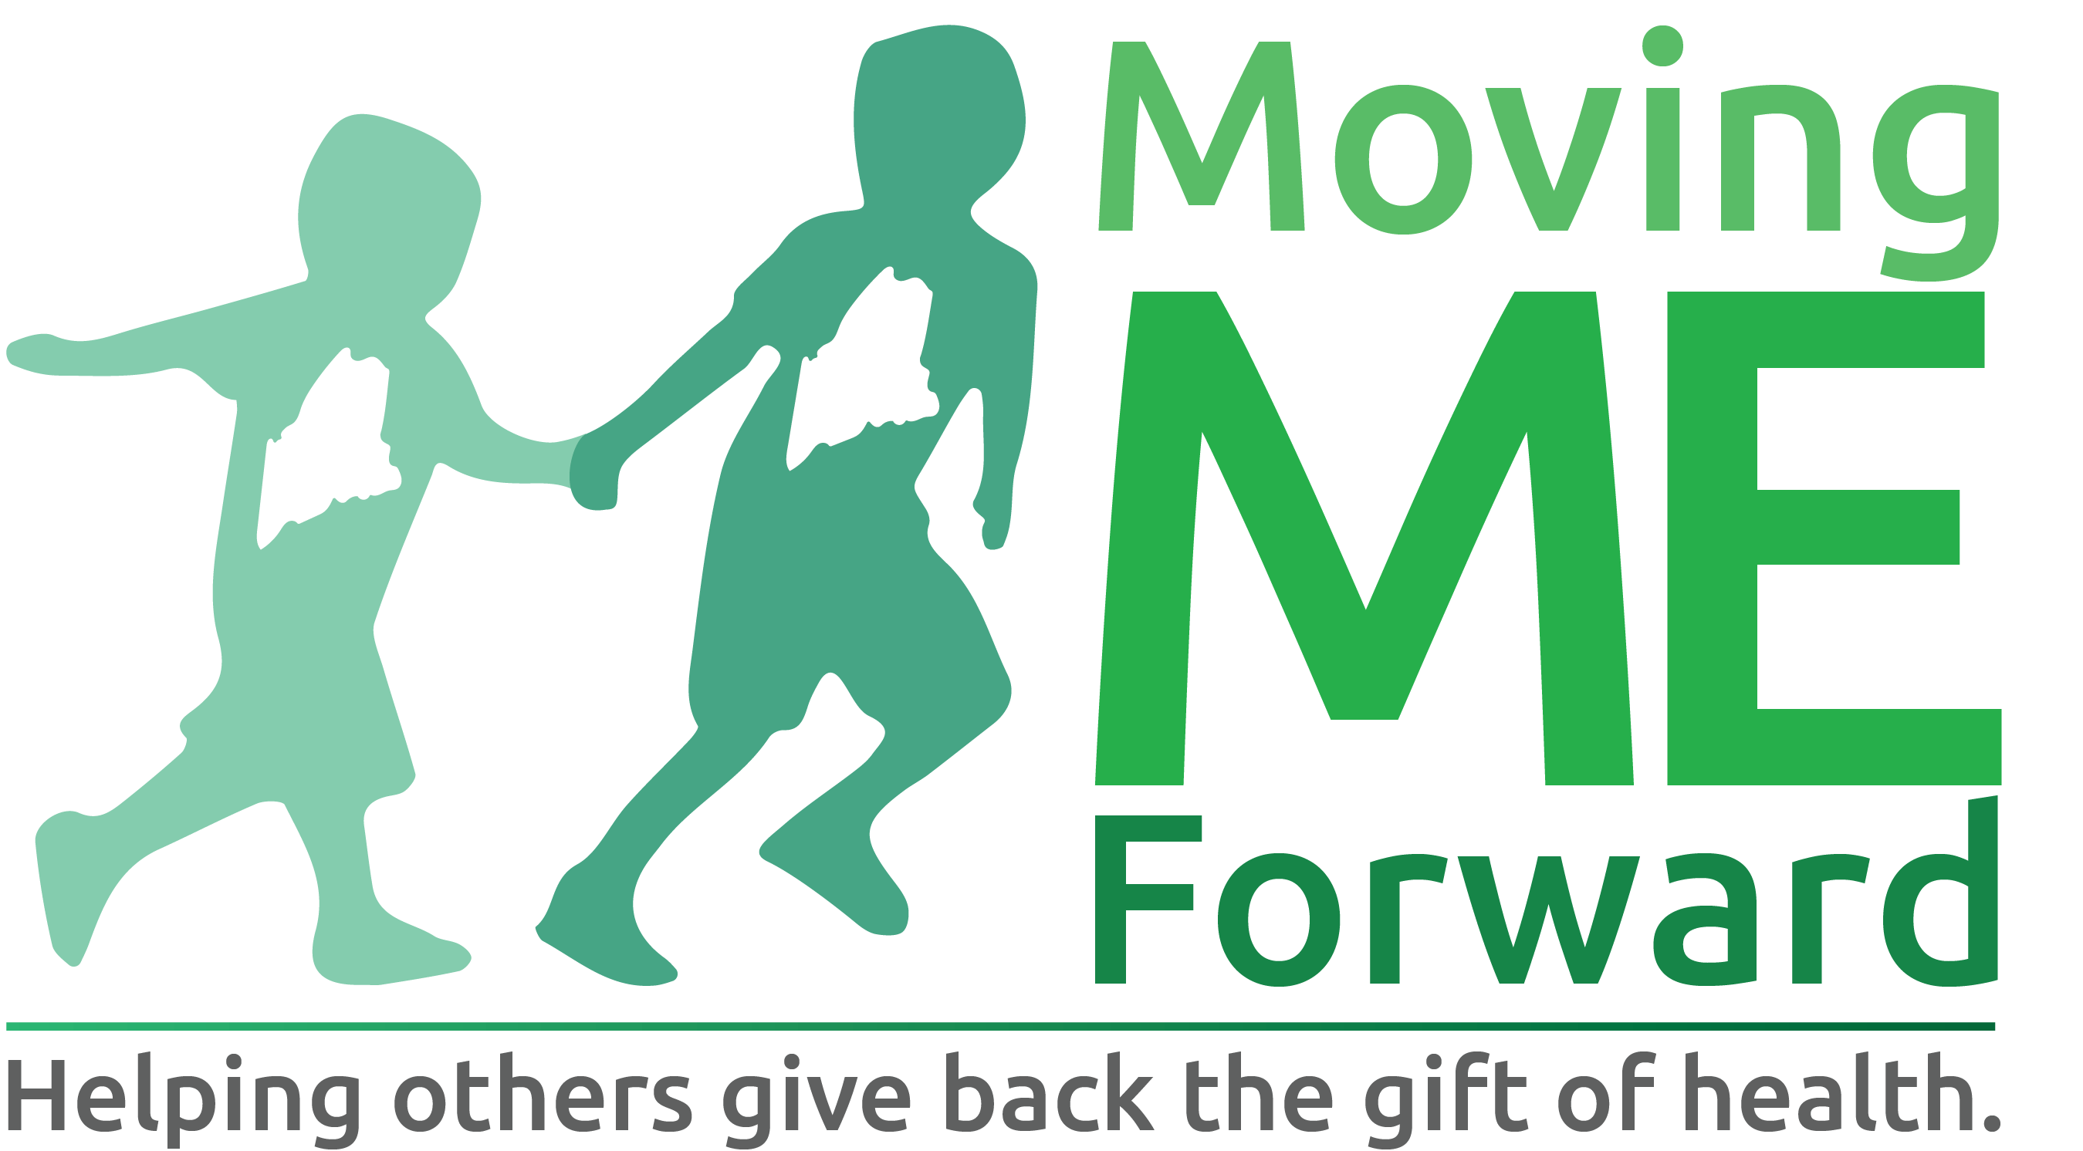

Moving ME Forward helps others “Give Back the Gift of Health” by funding innovative initiatives that promote sustainable health and fitness changes in our Maine communities.

What to know before you apply for a grant:

Funding priorities

Moving ME Forward requires proposals that create social change in the areas of health and fitness include a component that:
- Develops/promotes community connections
- Encourages social responsibility/giving back to the community
- Addresses ongoing sustainability
- Are partially funded by in kind donations

Who is eligible to apply
- Students, graduates and affiliates of Central Maine Community College
- Nonprofit 501(c)(3) federal tax-exempt organizations

When to apply
- Grant application period is open from September 1st thru December 31st.

- What to submit
- Requests should be for future expenses only. Awards for grants will be made by March 1st. Project start date should take this into consideration.
- Requests should not exceed $10,000
- Please only send information and materials requested in the grant program guidelines/application. Additional materials will not be reviewed.
- All competitive grant program awardees will be required to submit a Project Progress Report. If the grantee fails to submit one, further funding will be held until the missing report is filed.

Types of funding (often supported)
- New projects: activities that are distinct from ongoing programs and that have start and end dates.
- Expanding projects: the extension of a successful program to a new population or geographic location or to include a significant change in scope.
- Capacity building: projects that will strengthen an organization’s efficiency or effectiveness and that have clear goals or outcomes. For example, board training to develop fundraising capacity with specific goals.
- Capital expenses: can be part of the budget for a new or expanding project if they are necessary and directly related to the outcomes of the project, including materials and equipment.
- Personnel expenses: any staff salaries must be directly tied to a new or expanding project.
- Indirect costs: administrative overhead expenses of up to 20% of the total requested budget. When allowed, these should be included in the budget and labeled “Indirect costs.

Types of funding (often not supported)
- Operating support: ongoing administrative costs such as rent, utilities, office supplies, salaries (not tied to a specific project expense).
- Ongoing activities: continuing programs or projects that have no clear end date.
- Endowments or capital campaigns: activities leading up to a capital campaign such as feasibility studies as well as costs related to verbal or written requests for financial support such as fundraising events or appeal letters.
- Camp scholarships: funding for admission, enrollment, tuition, or other costs related to individual or group attendance at a short-term recreational or educational program.
- Capital expenses: purchases of property, equipment, or building materials related to the organization’s core operations.

Grant Process Timeline
- Application intake/Eligibility prescreening: grant application period is open from September 1st thru December 31st. Applications are reviewed as they are received to determine if required grant program criteria are met.
Grant application review: eligible applications are assessed by assigned Moving ME Forward board members and summary reviews written.
Grant decision meeting: summary reviews are presented to Moving ME Forward Board of Directors and final award decisions are made as a committee.
Notification: All applicants will receive a letter through regular mail notifying by March 1st as to whether their request has been funded or declined.
Evaluation: All grant recipients are required to submit project progress reports for review by the Moving ME Forward Board of Directors at 6 month intervals and at the completion of the project.

Application Confidentiality
- Applications may be shared with interested parties, including donors for potential funding.

