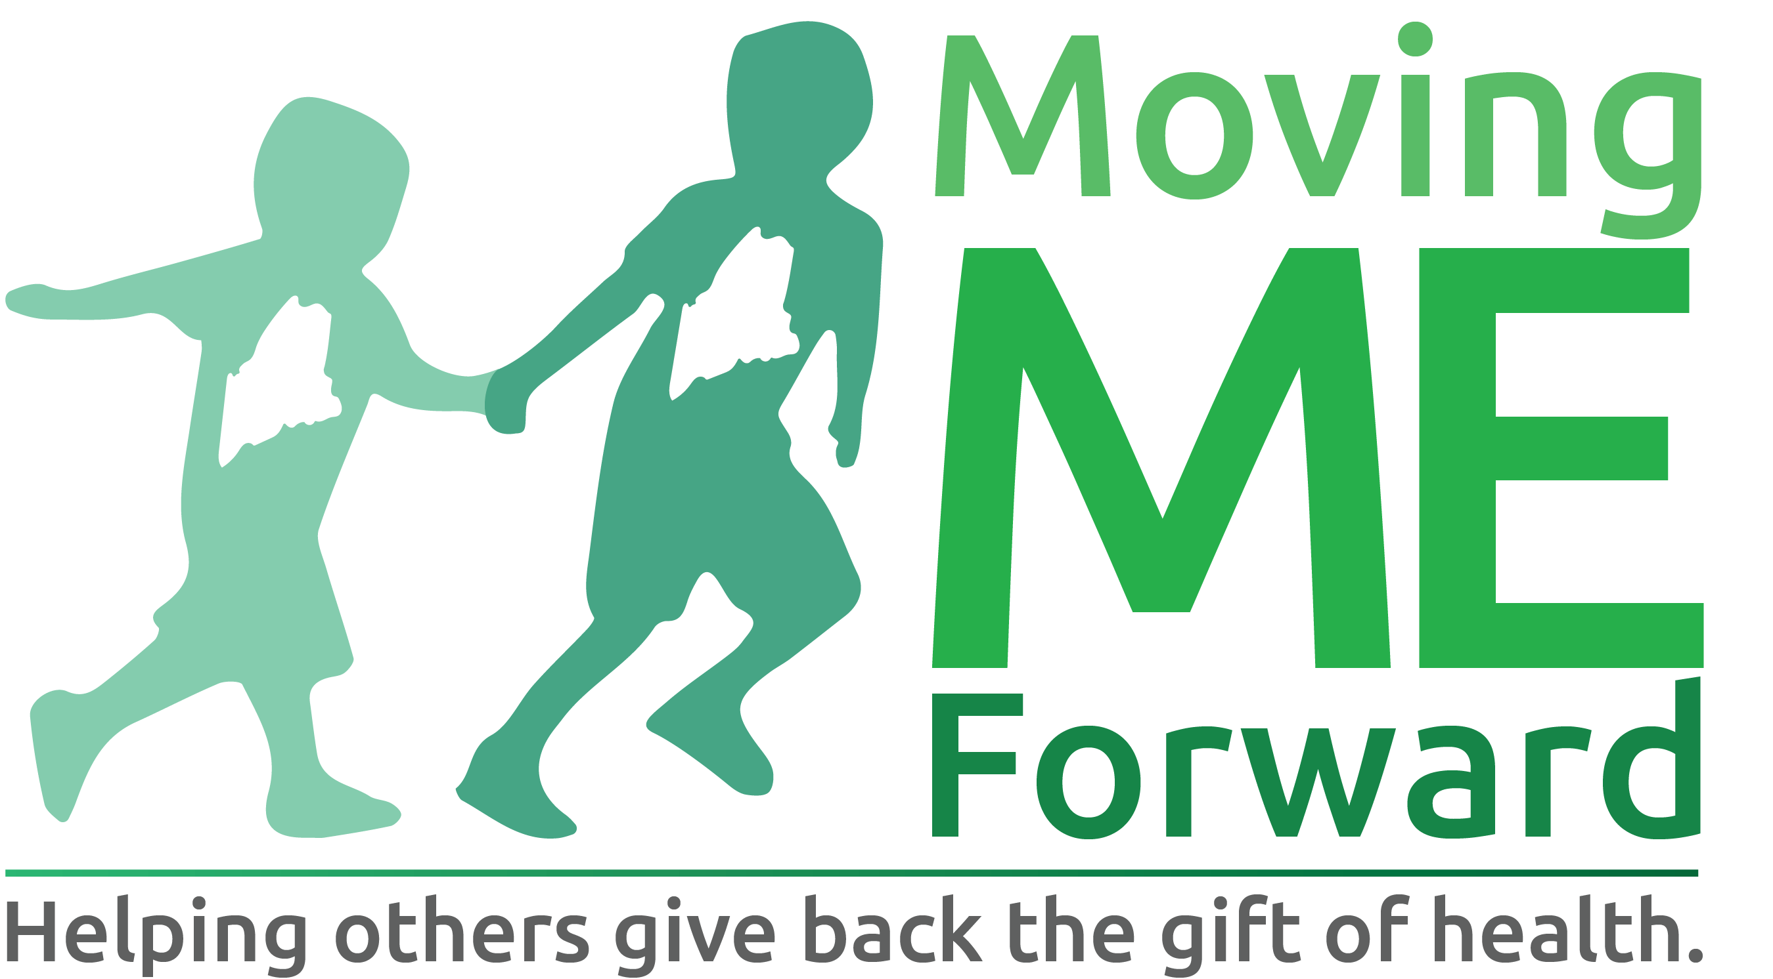

APPLICANT INFORMATION
Primary Contact Name:
Address:
Phone number:
Email address:
Affiliation:
☐ Student, Graduate or Affiliate of Central Maine Community College
☐ Nonprofit 501(c)(3) federal tax-exempt organization: ________________________________

PROJECT INFORMATION
Amount Requested from Moving ME Forward:
Total Project Budget :
Primary County Served:

One-Sentence Project Description
Complete the following sentence in 25 words or less: I/We request support to...

Narrative Section: Use up to 200 words for each of the following unless otherwise specified.
Overview
Provide a description of your project, including the overall goal and community need(s).

Outcomes
List up to three specific results you hope to achieve. Include a brief explanation of how you will track your progress and/or measure your results.

Impact
Explain how this project will promote sustainable health and fitness changes in our communities.

“Giving Back” Component
Describe how the concept of “giving back” is incorporated into this project

Activities
List up to five specific activities you will do to achieve the results and impact you described above.

Partnerships and Collaboration
List any organization that you will partner with to make this project successful. Include a brief description of what each partner organization will do in this project.

Population Served (50 words or less)
Describe the people who will most benefit from this project. Include an estimate of the number of people who will directly benefit from or participate in your project.

Community Involvement
Select all of the ways that community members will be involved in this project

Key Personnel
List the specific roles, responsibilities and qualifications of key personnel for this project

Section 3 PROJECT FUNDING
Project Timing
Identify the start and end dates of the activities you plan to fund with a Moving ME Forward grant.

Project Revenues
In this section, list all of the funding sources you have identified for your project. This includes grants from other foundations, in-kind donations (donations of time, goods or services from your organization or others), or earned income.

Example Format:
Name of Funding Source | Amount | Status (Pending or Secured)
Total

Project Expenses
Please list the specific items or expenses needed for your project under Expense Items. For each item, list the amount you request from Moving ME Forward in Amount from Moving ME Forward. List the amount you will need from other sources in Amount from Other Sources if that applies.

Example format:
Expense Items | Amount from Moving ME Forward | Amount from Other Sources | Total Expense
Total

Budget Narrative
Describe how you plan to use the grant funds if you receive them and your plan for sustainability in 200 words or less. Please check the grant program guidelines for a list of what is eligible for support.

Authorization

I understand that if selected for funding, that references and background checks will be required for individual applicants prior to release of funds.

I certify that the information provided in this grant application is true and current.

For online submissions, my typed name shall have the same force and effect as my written signature:

Applicant Signature: ____________________________________________

Application Date: _________________

Please Note:
If unable to submit the grant application online, a typed application, using this template is required. Hand written applications will not be accepted. Offline applications should be mailed or delivered to:
Moving ME Forward
Attn: Bob Brainerd
21 Millett Drive
Auburn, ME 04210

